EXPERIMENT-4

**Uid: 2022301002/2021300101**

Name: Viraj Bhalerao/Adwait Purao

Branch: Comps B

Batch:B2

* **Problem Definition:** To design sequence diagram and the state chart diagram for Ferry Ticketing System
* **Theory:**
* **What is sequence diagram?**

A sequence diagram is a Unified Modelling Language (UML) diagram that illustrates the sequence of messages between objects in an interaction. A sequence diagram consists of a group of objects that are represented by lifelines, and the messages that they exchange over time during the interaction.

A sequence diagram shows the sequence of messages passed between objects. Sequence diagrams can also show the control structures between objects. For example, lifelines in a sequence diagram for a banking scenario can represent a customer, bank teller, or bank manager. The communication between the customer, teller, and manager are represented by messages passed between them. The sequence diagram shows the objects and the messages between the objects.

For a particular scenario of a [use case](https://en.wikipedia.org/wiki/Use_case), the diagrams show the events that external actors generate, their order, and possible inter-system events. All [systems](https://en.wikipedia.org/wiki/Software_system) are treated as a [black box](https://en.wikipedia.org/wiki/Black_box); the diagram places emphasis on events that cross the system boundary from actors to systems. A system sequence diagram should be done for the main success scenario of the [use case](https://en.wikipedia.org/wiki/Use_case), and frequent or complex alternative scenarios.

* **What is collaboration Diagram?**

A collaboration diagram, also known as a communication diagram, is an illustration of the relationships and interactions among software [objects](https://www.techtarget.com/searchapparchitecture/definition/object) in the Unified Modeling Language ([UML](https://www.techtarget.com/searchsoftwarequality/definition/Unified-Modeling-Language)). Developers can use these diagrams to portray the dynamic behavior of a particular [use case](https://www.techtarget.com/searchsoftwarequality/definition/use-case) and define the role of each object. To create a collaboration diagram, first identify the structural elements required to carry out the functionality of an interaction. Then build a model using the relationships between those elements. Several vendors offer software for creating and editing collaboration diagrams.

## Notations of a collaboration diagram

A collaboration diagram resembles a flowchart that portrays the roles, functionality and behavior of individual objects as well as the overall operation of the system in real time. The four major components of a collaboration diagram include the following:

1. Objects. These are shown as rectangles with naming labels inside. The naming label follows the convention of object name: class name. If an object has a property or state that specifically influences the collaboration, this should also be noted.
2. Actors. These are instances that invoke the interaction in the diagram. Each actor has a name and a role, with one actor initiating the entire use case.
3. Links. These connect objects with actors and are depicted using a solid line between two elements. Each link is an instance where messages can be sent.
4. Messages between objects. These are shown as a labeled arrow placed near a link. These messages are communications between objects that convey information about the activity and can include the sequence number.

The most important objects are placed in the center of the diagram, with all other participating objects branching off. After all objects are placed, links and messages should be added in between.

* **Output:**

1. **Admin Sequence Diagram:**

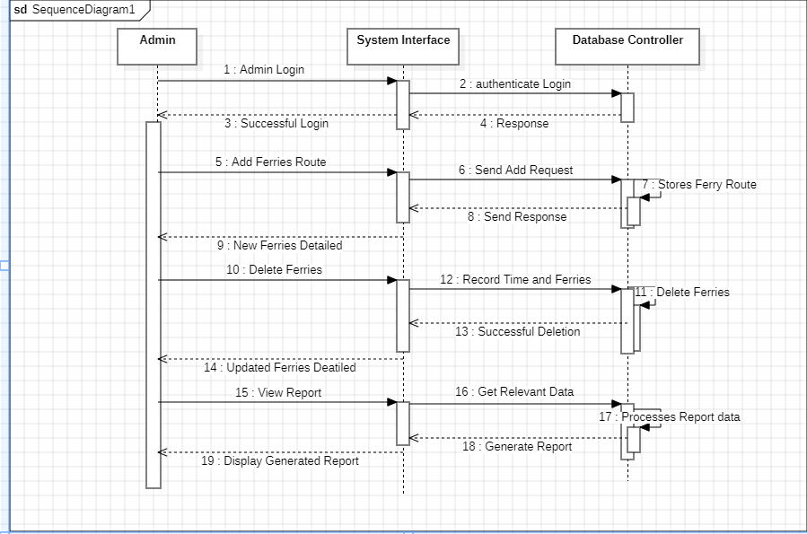

1. **User Sequence Diagram:**

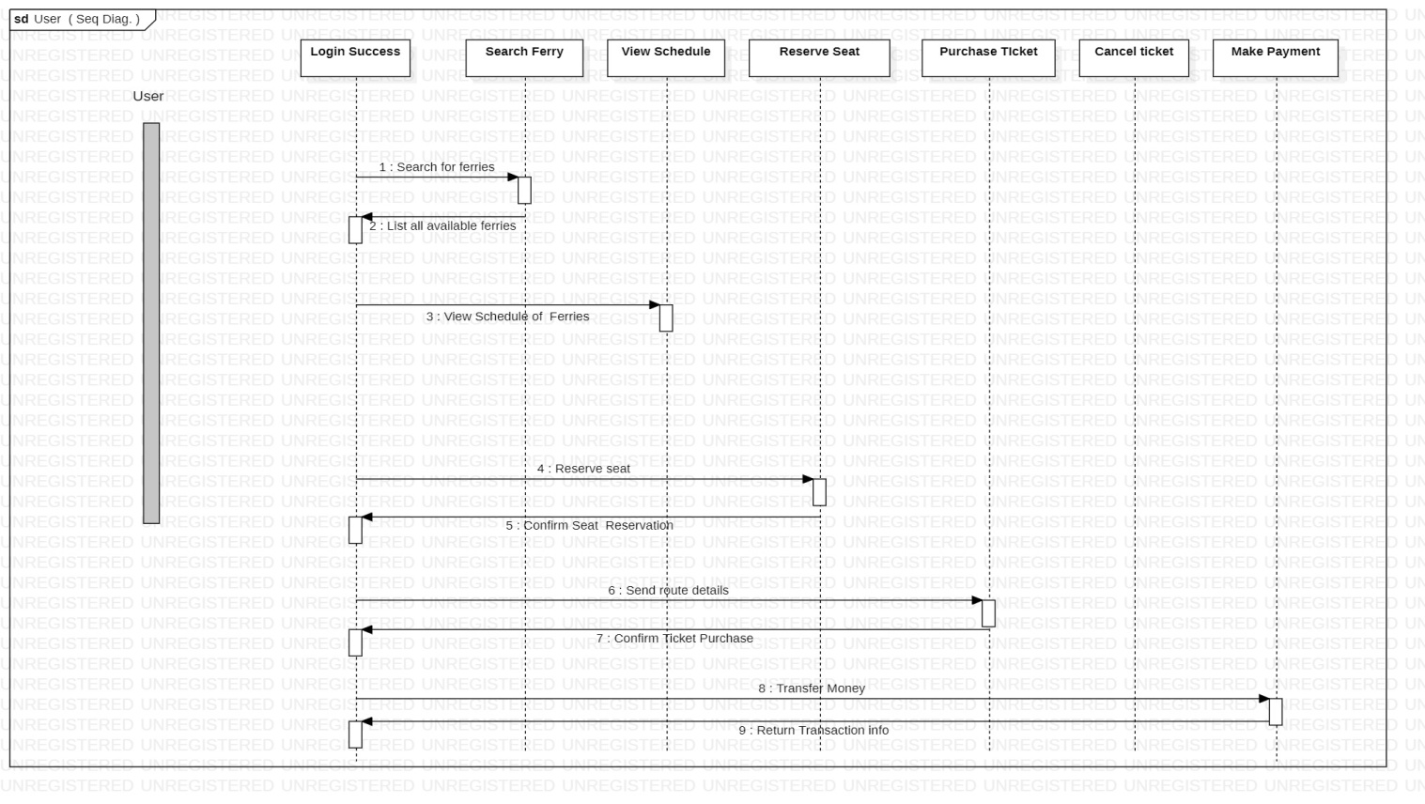

**3.Collaboration Diagram:**

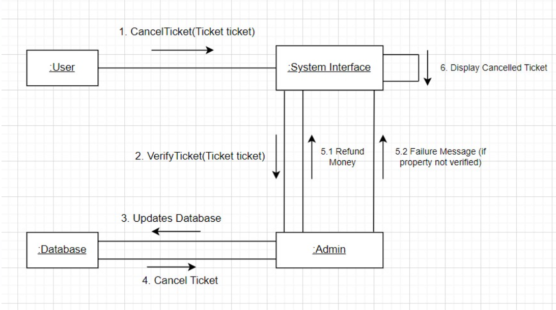

* **Conclusion:** Thus, we have created the sequence and the collaboration diagram for Ferry Ticketing System.